THE SANFORD STEWART HOUSE
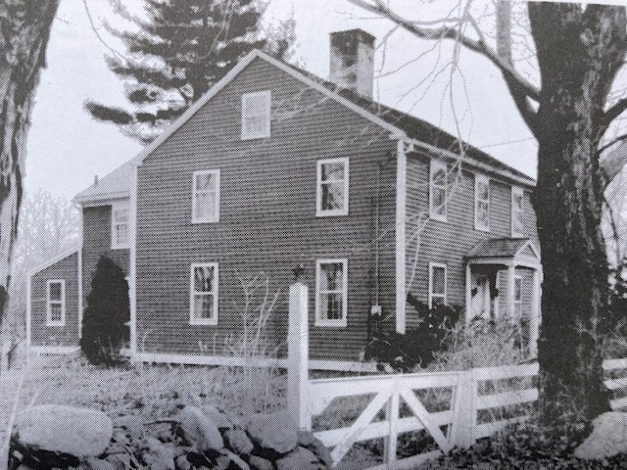
This 3 bay, 2.5 story, central chimney house stands on a level wooded lot facing Penfield Hill Road, at its intersection with Great Hill Pond Road. It was built in the Federal period (1827) but retains the basic architectural structure and form of its Colonial period antecedents.
The two story, gable-roofed ell, which is specifically mentioned in the 1873 will of Sanford Stewart, extends from the rear of the structure; behind it a single story wing projects toward the east.
Two historic outbuildings still stand northeast of the house, and the lot is bordered along Penfield Hill Road by a white rail fence. There are three wells on the property – the most historic well retains its original stone surround and capstone.
The building’s post-and-beam pegged frame rises from a granite block foundation and its brick chimney is centered at the apex of a shallow pitched, gable roof. Its cedar shingles have been replaced with asphalt shingles over substrate, but could be easily restored to cedar.
Windows throughout the second story have 8/12 sash; the first story displays 12/12 sash. Seven windows in the ell have been replaced, but the original sash were retained and could be replaced.
A brick walkway and granite stoop, with period boot scraper, leads to the central façade feature, a gable roofed portico supported by a pair of smooth anntenuated Tuscan columns, which is likely part of the building’s original construction. An original paneled door with heart shaped Suffolk latch graces the entrance.
Red aluminum siding highlighted by white trim currently covers the building, yet a section that has been removed reveals 4” clapboards in fine condition, suggesting that the original siding is extant beneath the covering and could be restored.
The interior is in remarkably original condition, featuring original oak flooring, original paneled doors with hardware, a main staircase and back staircase, feather and bead wainscot and enclosed corner posts. There are four fireplaces – each originally designed – two with cooking cranes, one with granite cheek stones, all with granite lintels, a beehive oven in the keeping room, and original hearthstones. There are three on the first floor and one on the second floor, though it is possible that a fifth fireplace exists that has not yet been revealed. Two doors have been removed from the living room, but were retained and could be replaced.
All renovations to the property have been sensitive, in keeping with its historic provenance, and are reversible should a future owner wish to return the home to near-original condition.
The grandson of Captain Daniel Stewart who established the family in the Penfield Hill area during the 1770’s, Sanford Stewart (b.14 January 1797 – 2 May 1874) had this house built for him between 1827 and 1830. In 1819 his father James (see Brown-Stewart House (1789), also on Penfield Hill Road) willed him the 20 acre “Shepard lot”, which Jonathan Shepard had sold to the Stewarts in 1812. Curiously, Sanford sold the empty lot to Samuel Ackley, for $35 in 1827, and repurchased the property with a house on it, for $700, in 1830. Sanford Stewart married Sally Shepard of Middle Haddam (b.7 November 1797-22 October 1859) in 1832, and ran his farm and sold timber in the area until his death in 1874, when the main portion of the house was devised to his daughter Sarah and the rear ell and remaining property went to his son John. Evidence of this split can be traced through the building’s architecture.
Built in the late Federal period, the house is particularly interesting as an example of the persistence of 18th century architectural forms in the outlying rural areas of Portland during the early 19th century.

Prepared by Dr. Margaret McCutcheon Faber
Sources: Primary observations from site inspection; Town of Portland Land Records; J. Paul Loether: History and Architecture of Portland,1980.

