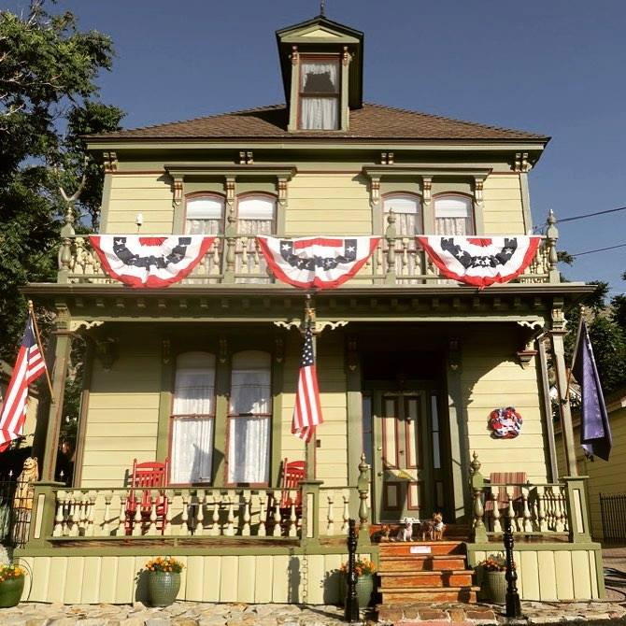

Cohn House

Cohn House | 24 A St t/ 66 A St | Virginia City, Nevada
Contributing Structure to the Virginia City National Historic Landmark District

Introduction:
- Cohn House is located historically at 24 South A St. The house was later renumbered to its current address of 66 South A St. Cohn House sits on Block 102 lot 13 and the carriage house and gardens are on lots 11, 12, 14. Cohn House has also been known as the Kenney-Spaulding House during the 20th century. Below is a photograph from approximately 1879.
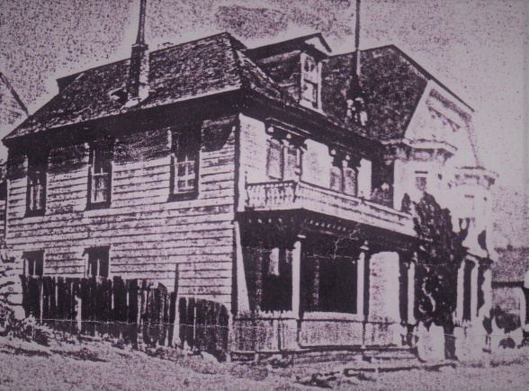
- Much of Virginia City was destroyed during the Great Fire of 1875. The fire started across the street at Kate O’Shay’s boarding house located at 23 South A St. The Territorial Enterprise reported that a strong west wind pushed the fire uncontrollably down to C St and much of Virginia City. Subsequently, in a Nevada Appeal article in 1989 titled Victorian’s Secrets…House was Built Prior to Great Fire, it was noted that the owner discovered that the front end of the parlor contained a rectangle of siding that had replaced a window. In an 1878 panoramic photo it was disclosed that the window already had been covered. Owner Dinah O’Brien stated “Why would anyone building a house in 1876 take out a window and board it over within 2 years?”. The drawing of the house pre-fire however; shows a home that appears to be a different and more substantial structure than post fire photos
- The following are the owners of home on lot 13 prior to the Great Fire of 1875:
- Hardy, R C to Virginia, Spencer
February 12, 1862 - $75
Book A Page 259
Spencer Virginia listed in 1862 NV Territory Directory as a miner residing on west side of A Street near Taylor. Stephen Virginia also resided there (brother?)
- Virginia, Spencer to Jacobs, Michael
June 7, 1862 - $200
Book B Page 601
A M Jacobs listed in 1862 NV Territory Directory as a shoemaker residing on west side of A Street near Union.(Same? Just prior residence?)
- Jacobs, Mich to Jacobs, Morris
November 17, 1862 - $500
Book G Page 244
- Jacobs, Morris to Jacobs, Michaelus
May 19, 1863 - $1,200
Book U Page 86
A notation that this was a reconveyance back to original seller.
- Jacobs, M & Henryetta to Jacobs, Morris
December 8, 1863 - $700
Book V Page 126
- Jacobs, Morris to Haase, Samuel
January 11, 1865 - $1,475
Book Z Page 324
- Haase, Samuel to Cohn, Leyser
July 8, 1865 - $1,000
Book Z Page 601
- Cohn, L to Jacobs, Ephraim
January 6, 1868 - $240
Book 32 Page 336
- Jacobs, E to Jacobs, M
October 10, 1872 - $200
Book 33 Page 174
A Michael Jacobs listed in 1873-74 Directory as a shoemaker residing on east side of Howard between Union and Taylor
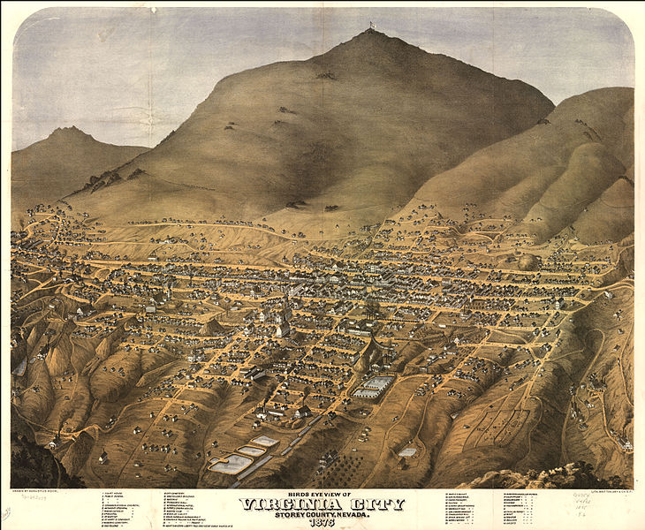
Pre-1875 fire drawing National Archives

- Cohn House: Present Structure. CIRCA 1877: Owners and Occupants
- Jacobs, M to Lonkey & Smith (Lonkey, Oliver & Smith, E R)
December 29, 1877 - $6,000
Book 41 Page 651
- Smith, E R & F J to Lonkey, Oliver
February 19, 1885
Book 46 Page 575
- Cohn House: 24 South A St. Block 102 Lot 13 (post 1875 fire)
- Cohn Family. Morris David Cohn (age 50) and his wife Ernestine (age 30) who emigrated from Prussia/Germany lived the house. This was verified in the 1880 US Census Record. The Cohn’s three daughters were born in Virginia City; Selena (born 1977), Davisa and Eva. Three servants lived in the home and immigrated from Ireland. The photo below: is believed to be Selena Cohen (circa 1880) on the same second story deck that remains today. The house has been named Cohn House in honor of the Cohn family and the heritage of several of the earlier owners and occupants. The William Manning Family (husband, wife and son) also appear in the 1880 Census for 24 A St. and may have lived in the west side structure on the property fronting on Howard St.
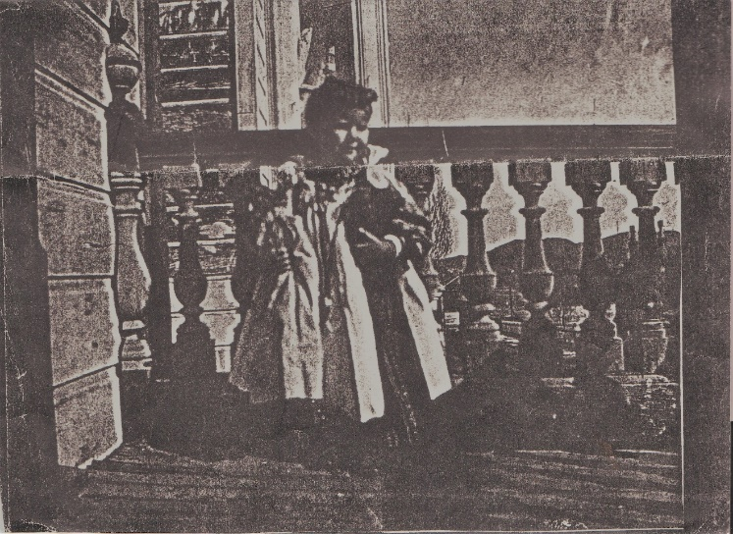
Cohn House Front Balcony: Cerina Cohn about 1880
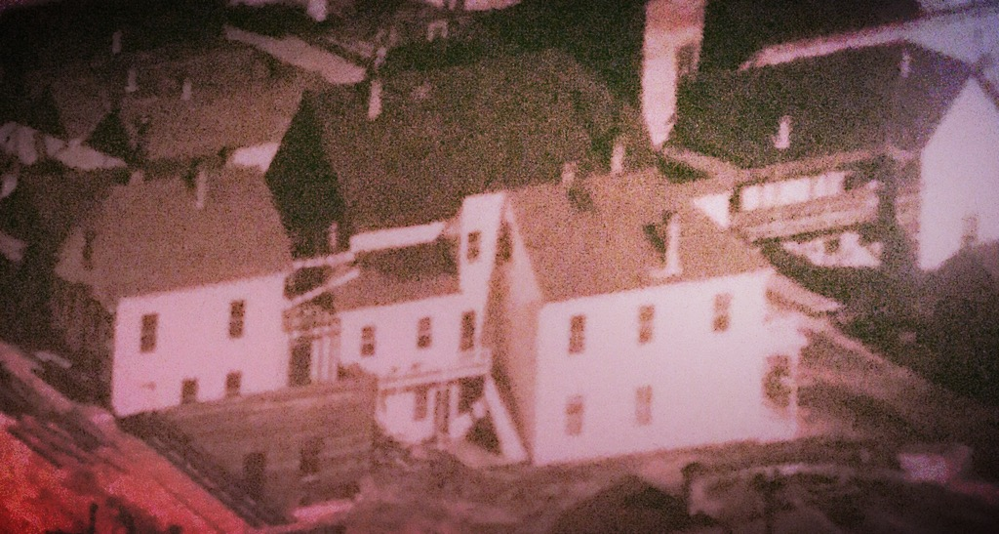
Cohn House from 1878 panoramic photo
- Title records show that in 1877 lot 13 was sold by M Jacobs to Oliver Lonkey and E. R. Smith. Lonkey and Smith owned the Nevada and California Lumber Company and Verdi Planning Mill. Upon Oliver Lonkey’s death his estate sold the home (lot 13) to RS Meacham in 1904. If the original house burned in 1875 then Oliver Lonkey may have been the builder of the house that now sits on lot 13. The construction of the house is of high grade wood and timber and may have led to its longevity. It is unclear if Lonkey ever lived in the home and is listed in the 1980 census as living at 48 South A St with his wife nieces and nephew. Oliver Lonkey also appears on census rolls in Verdi where his home which was known as the Lonkey Mansion (built in 1860). Lonkey was a prominent businessman and his business in Verdi sold for $1,000,000 at his death. The Lonkey mansion in Verdi was later moved to Reno. Oliver Lonkey is listed in the 1878 Directory residing at 48 South A Street, Lonkey’s brothers are listed as residing at 107 Carson. (Eli, Oliver, William, and Xavier) Leon Lonkey at 338 south C (Nevada Lodging House, proprietor). E R Smith is listed as residing at 102 North
- Frank Spaulding and later Everette Loftus Kenney lived in and owned the house from the 1930s to the late 1940s. Spaulding is described in US Census records as the half-brother of Everette L. Kenney. Helena Sneade Kenney appears to have been the mother of both Spaulding and Kenney. All appear in census records and at various times as owners of the property. Kenney and Spaulding were also partners in the Pride of the Washoe Mine. Everette Kenney died in 1949 at Washoe Medical Center of Tuberculosis. Title passed to David C. Kenney from Everette Kenney in 1948

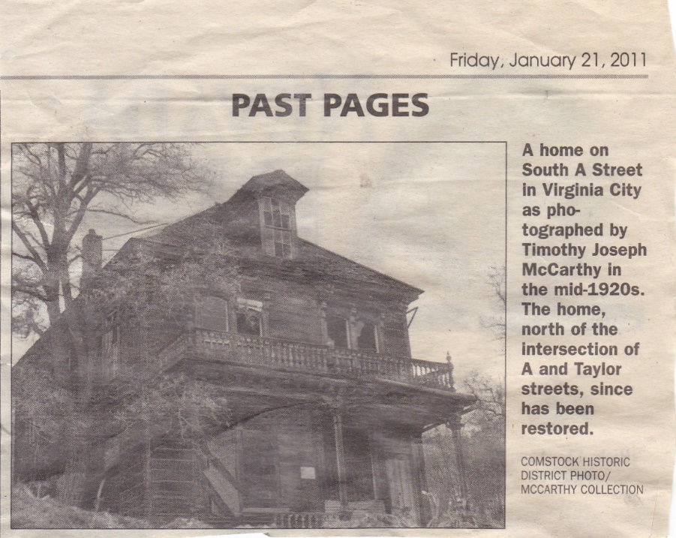
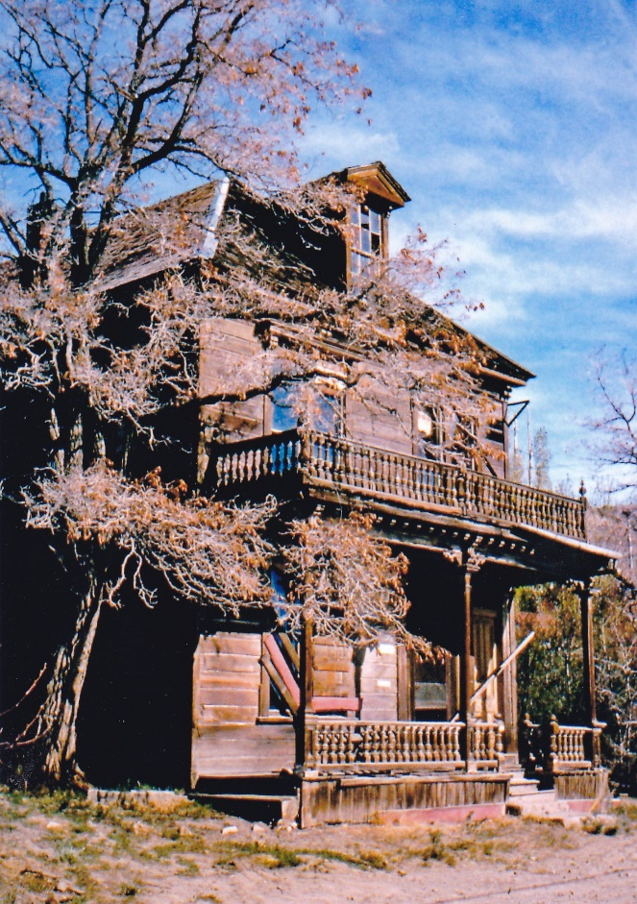
Circa 1960s prior to restoration

20th Century Owners: Block 102, lot 13
- Lonkey, Camille (Executor) & Marie (Widow) to Meacham, R. S.
November 9, 1905
Book 55 Page 469
- Meacham, R. S. Deceased June 10, 1912
- Kenney, H Estate to Storey County Treasurer Agnes Hamilton
1931
Information obtained from Treasurer’s Delinquent Tax Records
- Storey County Treasurer Agnes Hamilton to Kenney, E. L.
July 21, 1932 - $12.37
Book 61 Page 40
- Kenney, E.L. to Spaulding, Frank W
November 28, 1936
Book 62 Page 331
- Spaulding, Frank W. to Kenney, E.L.
January 20, 1947
Book 62 Page 541
- Kenney, E.L. to Kenney, David C.
June 28, 1948
Book 63 Page 110
- Kenney, David C to Flanagan, John
March 31, 1956
Book 64 Page 41
- Flanagan, John to Flanagan, Jack
- Krieger, Poole S to Jordt, David K & Rita S
June 13, 1973
Book 68 Page 59
From the time of Kenney’s death in 1949 until the house was purchased by David and Rita Jordt (geologists) the home had seven different owners. From the looks of the house in photos, probably very few of the owners actually lived in the house during those 28 years. An exception is Poole S. Kit Krieger (sold the home to the Jordts in 1973) who commissioned a new roof and lived on the second story. Krieger sold the house to the Jordts for $10 with the stipulation in the deed that the house be kept in conformity with the original architectural design
- The Jordt’s embarked on major restoration and renovation work which included jacking up the house and pouring a foundation, installing insulation, electricity and upgraded plumbing. The original hot water based central heating system was also installed. The structural restoration work that the Jordt’s completed literally saved the house.
- In 1979 Dinah O’Brien purchased the home. She commissioned the rock retaining wall on the west side of the house and the front stone sidewalk and implanted cedar rounds in the paths on the terraced pathways. She also scraped and filled the gingerbread moldings to historical accuracy. See article below from the Nevada Appeal 1989.
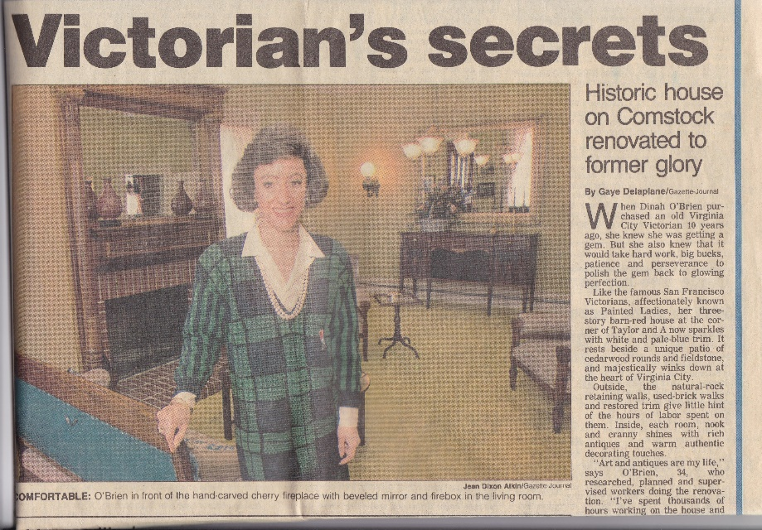
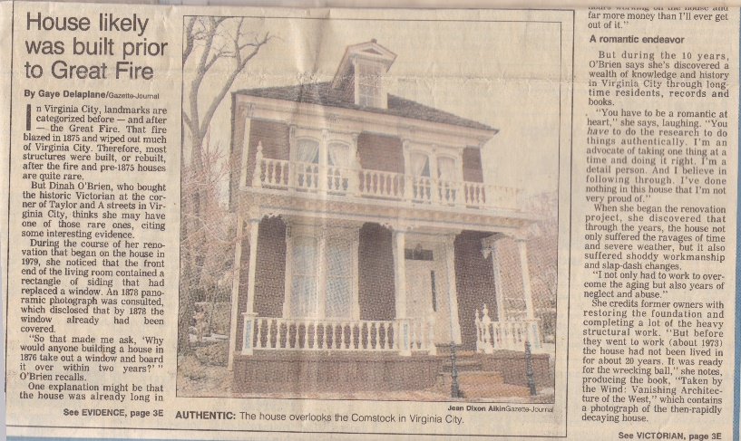
- In 1989 Jeff Teague and Paul Yandre purchased the property. They commissioned the extensive restoration of the downstairs parlor and the second-floor bath, along with the gardens. Yandre and Teague are prominent Virginia City business owners who contributed to restoration efforts throughout the Virginia City Historical District as well as lobbying for the Virginia and Truckee Railroad. In addition to renovation of the Cohn House, they renovated, owned and operated the Cobb Mansion Bed and Breakfast Inn on A St.
- In 1994 Tom and Becky Purkey purchased the home. They continued to enhance the long-term viability of the property with roof and deck improvements, window repairs, painting and plantings. Ms. Purkey is a local historian who conducted tours of historic homes.
- In 1999 the home was purchased by Martha McKay and Pete Kraemer. Ms. McKay had extensive restoration experience and indeed after she sold the house in 2005 she moved back to restore her family’s historic Snowdon Horse Shoe Plantation near Memphis. Ms. McKay’s husband Peter Kraemer (musician, photographer and artist) also contributed to major restoration work including the installation of heated floors and a new kitchen. The copper bar in the kitchen is unique and a work of art. Ms. McKay also commissioned the repainting of the house into a green and red three paint color schemes. A beautiful Victorian wrought iron fence was commissioned between the south front and side yard.
- Current owners Mark and Deborah Quam purchased Cohn House in 2005. The property includes block 102 and lots 11, 12, 13, 14. Mr. Quam is retired from the construction industry and fire department is the San Francisco Bay Area. Mr. Quam also conducted tours on the Virginia City Trolley. Ms Quam is a Registered Nurse Care Manager in the Bay Area. After constructing a new retaining wall, a carriage house style four car garage was built (lot 11,12) next to (but detached from) the house by builder Jim Collins. The front porch was releveled and undercarriage of porch was rebuilt by Mr. Quam. New redwood from Cazadero California mill was laid to the porch flooring. Renovation of the back room of the house was completed so that the rear bedroom would have a closet and storage space with an entrance to the upper level terraced garden.
- A new roof was commissioned in 2005. A new hot-water boiler unit was commissioned in 2014 which converted the heating system fuel source from heating oil to propane. The old below-ground oil tank was filled with the supervision of Story County Building Department.
- A floating oak floor was constructed over the original flooring in the master bedroom and hallway. Moldings and trim in the master bedroom and entry way were repaired with additional crown moldings applied in keeping with 19th century design.
- The house was repainted on the inside and outside using a Victorian color scheme. Gold leaf paint was added as a fourth color to the outside Victorian motif.
- Extensive restoration work was undertaken to the original double hung windows.
- The whimsical back fence and terracing have been repaired due to damage from high snow fall winter in 2016-2017.
- The front stone walkway was repaired. Interlocking red brick rear patio, walkway, breezeway and driveway were commissioned in 2006. A hot tub area and cement patio behind the new garage were added. A Victorian style fence was constructed between the garage and house in 2017. The front and side porch railings were repaired and painted in Victorian style detail.

Enterior and entry way
The three-story structure is Italianate in style with paired sash windows and molded cornice and brackets. The exterior is detailed in four levels of color---light green base paint, dark green trim, red trim and gold leaf. The paneled vestibule is original to the house, as is most of the siding and decorative trim. The house is framed in old growth redwood thought to have been brought by wagon from the forests of California by a Mr. Frazer. The redwood framing and siding are a major factor in the longevity of this structure through the many years of neglect in the early and early and mid-20th century. The timbers supporting part of the pass through under the rear of the second story wall are from timbers from the old Blue Sphinx Mine in Rawhide.

The 19th century lamps thoughout the house
The ornate oil lamps have been wired for electricity, but are still usable with oil as a fuel source. Most of the lamps are of colonial German and Dutch origin and were purchased by the Jordt’s in Surabaja at the East end of Java where they lived and worked during exploration geology work. In the master bedroom, the bejeweled Moorish ceiling lamps are from Ragastan India from a Victorian hotel.

parlor
The formal front parlor is reminiscent of the Victorian style of the gilded 1890s. The floor is Brazilian cherry wood with black walnut accent. The Anglo-Japanese wall coverings are hand-blocked Bradbury and Bradbury silk-screen papers. There are 16 levels of embellishments in the Aesthetic Movement wallpaper, which was designed by Paul Duchshcherer. Deborah Thomas served as interior design consultant, hung the wallpaper and painted the faux-woodgrain finish (highly popular style during the mining boom years) on the sliding French doors and the moldings and trim. The French doors originally divided the parlor in half, but were moved to open up the space. The colors of the wallpaper were chosen to keep the rosy glow of the rooms as they would have appeared in the 1890s by gaslight.
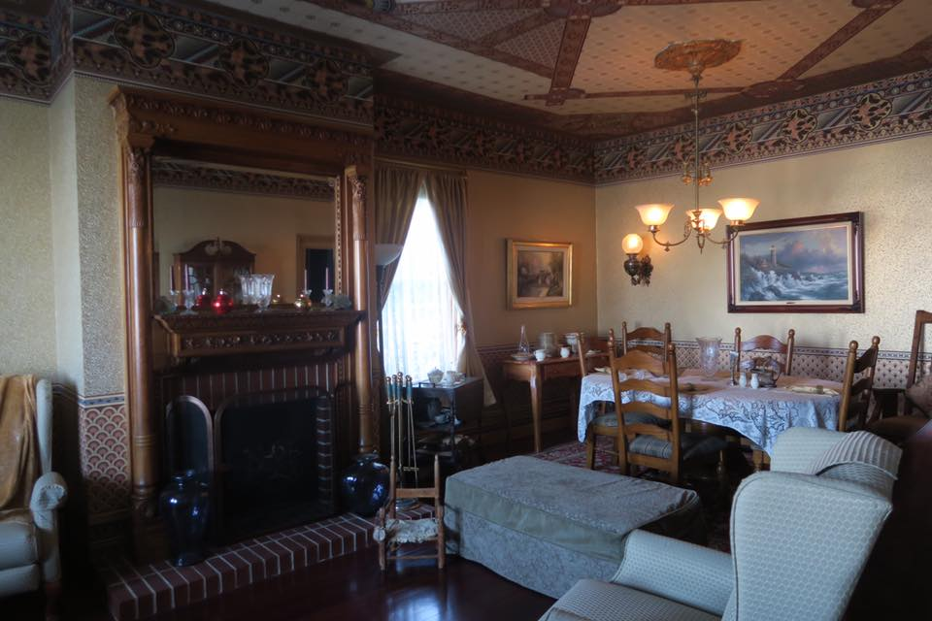
The buggy chair in the photograph below belonged to the current owner’s grandmother Edwina when she was a child in the 1890s. Other antiques in the parlor are from both of the current owner’s grandparents, Edwina Black Johnson of California and the Alfred Kroenkes of Cleveland.

The fireplace mantel is from the 1880s and is hand-carved Cherrywood. It was originally from a Bunker Hill mansion in Sterling City, California, an elegant and historic area near Los Angeles.
The brass door knobs found on the doors throughout the house are from the fabled Palmer House Hotel in Chicago.

Dining room
The chandelier is bronze guilt. It retains its original gas cocks and is weighted to be raised and lowered. The lamps of both side of the dining room are original oil lamps, now wired for electricity.

kitchen
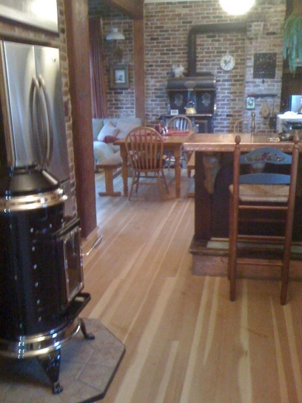
The ornate wood stove and manufacturers plate was purchased by the Jordts in Quincy California during the 1970s renovation. The kitchen maintains much of the 1860s charm with modern appliances such as a commercial grade gas Wolf range and stove. The wainscoting and beams are original. The glassed spice cabinet and pantry have been in use since the 1860s. The original crank phone black box remains and the wall phone is operational. During the 1950s the black phone box once connected to a common switchboard which connected all the phones in Virginia City. The switch board can be viewed in the 4th Ward School. The granite counters are trimmed with copper and the copper bar was commissioned by owner Martha McKay to local artist Peter Kramer. The large porcelain country sink was added during the kitchen renovation in 2000. The wood floors are heated by the central heating system. The cabinetry and shelves are reminiscent are of the 1940s.

great room and kitchen
The great room served as the informal salon and a summer morning room. The bricks used to restore the walls (which were badly caved in when the Jordt’s bought the house) are recycled from an old bank in Yerington. The large French doors opening out to the terraced gardens are from the Burlington County Club. Note the little winged martini window in the door. The red curtains were sewn by owner Dinah O’Brien.
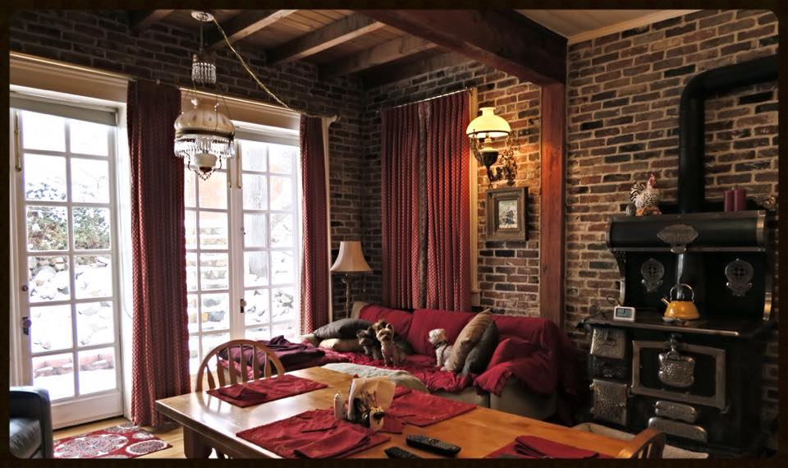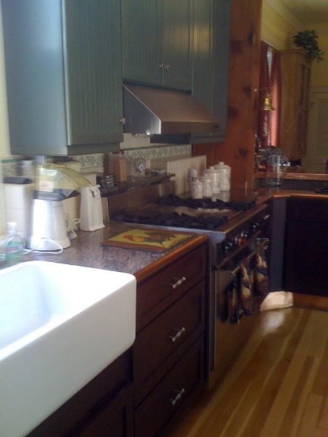

First Floor bathroom
This bathroom was renovated by owner Martha Mc Kay. The floor is marble with an antique bathroom sink and two gilded mirrors.

second floor stairway
The second-floor stairway is curved with 19th century molding and trim. It is thought that stairways of this design were to allow easier passage of a coffin to the first floor below. The oil lamp is from Germany and was manufactured by Ditmar Vin. It depicts winged Mercury, the messenger of glad tidings and good fortune.
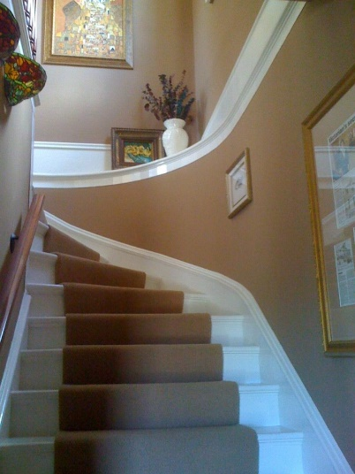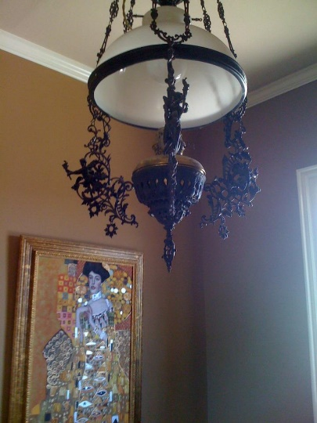

Front bedroom
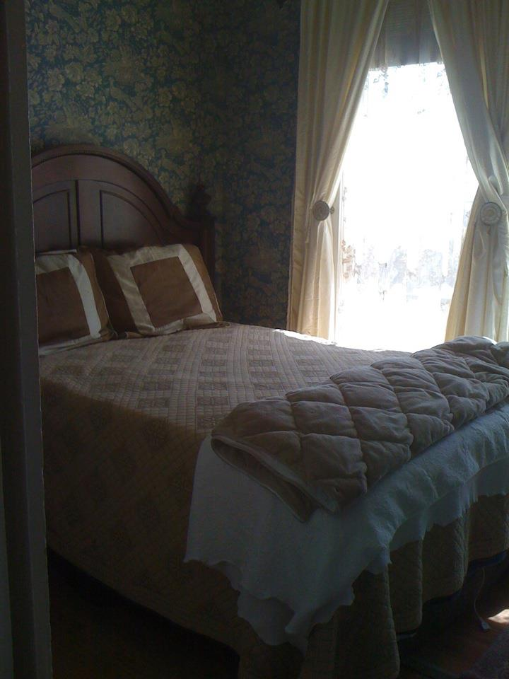
The front bedroom was originally a nursery or child’s room. The wallpaper was installed in the 1960s by owner Kit Krieger. The tie backs are white seashell with beaded trim.

bathroom
The bathroom is a full presentation of Bradbury and Bradbury wallpaper, commissioned by Yandre and Teague, the former owners. The English privy is made of Staffordshire porcelain and was purchased from a shop on Union St. in San Francisco. The toilet tank was retrieved from the old water company line shack still visible above the house on the slope of Sun Mountain. The tub is original to the house and the sink was installed in the 1960s. The porcelain tile was laid by local artisan Bruce Burke. The mirror over the sink is a Charles Eastlake.
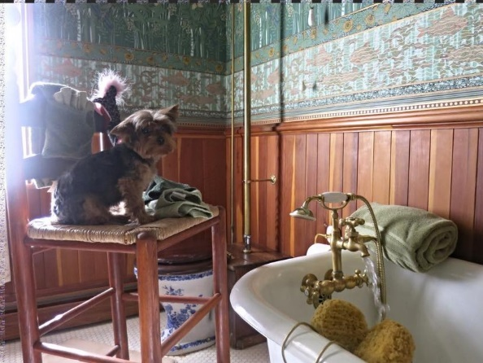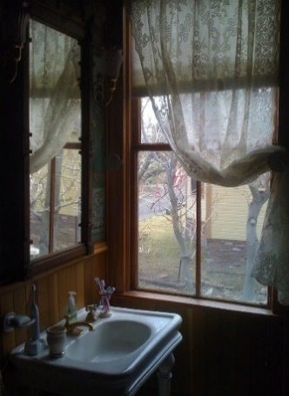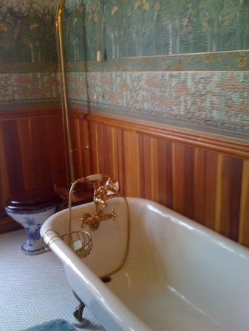

master bedroom and Sitting Room
Jeweled Moorish hanging lamps from Ragastan India hang in the bedroom. Crown molding were added in the master bedroom and sitting room. Oak floors were floated over the original fir floor. Pocket doors separate the bedroom from the sitting room.
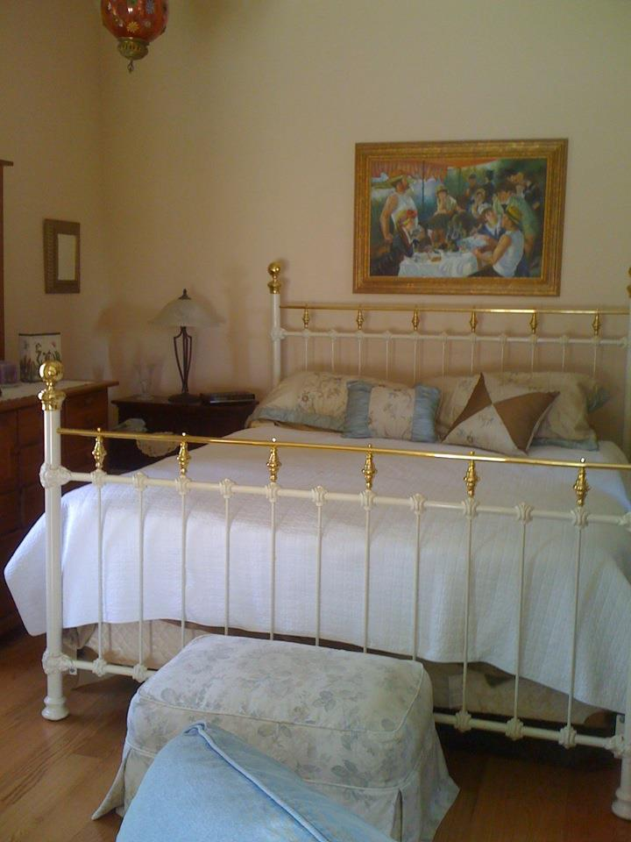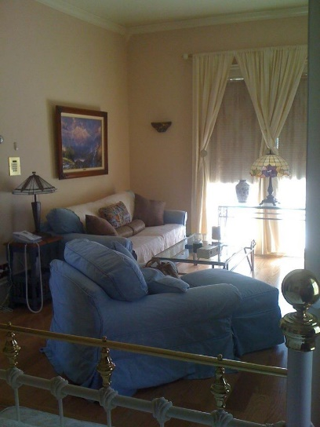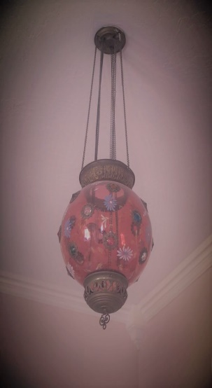

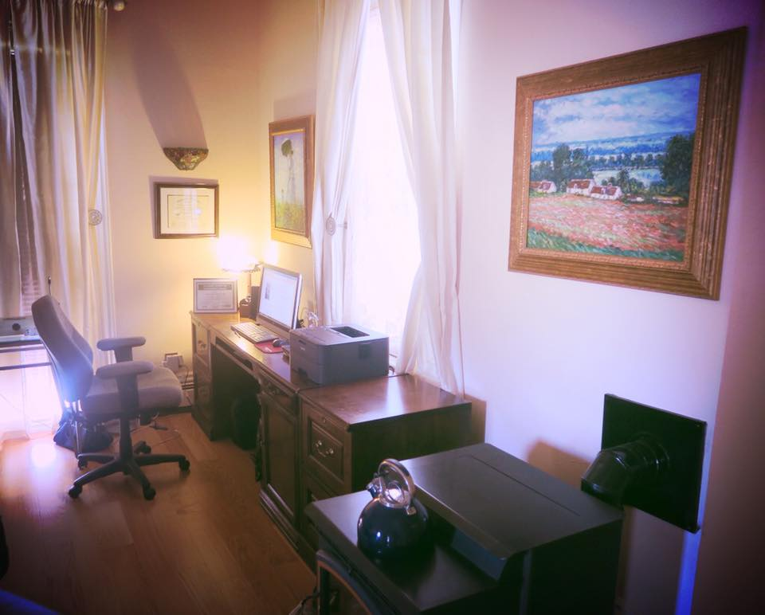
Home office and pellet stove added by present homeowners

Dressing room and walk-in closet
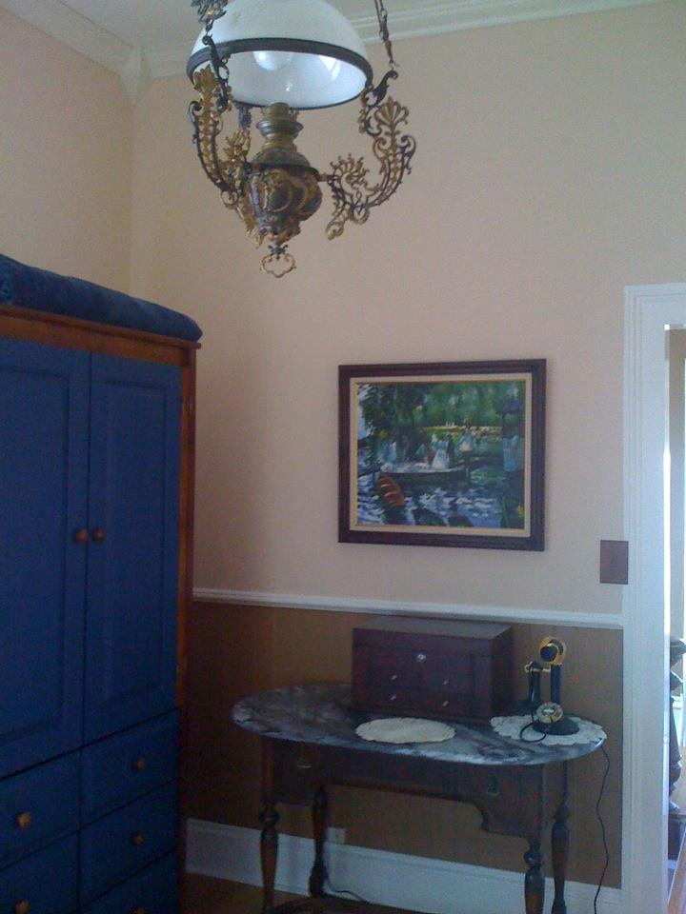
Note the oil lamp imported from Germany. Freestanding wardrobe in 19th century tradition. Antique phone from early 20th century. Crown molding was added by the owners in 2009 to duplicate molding throughout the house.

Library and gym
The library opens onto the side balcony for early morning tea and a view of Sun Mountain and the gardens. Note the tongue and groove ceiling which was commonly used in kitchens and back bedrooms. A small door opens to a stairway to the third floor that served as servants’ quarters in the 1880s when the Cohn family owned the house. A home gym was added by the current home owners so that the library has multi-purposes.
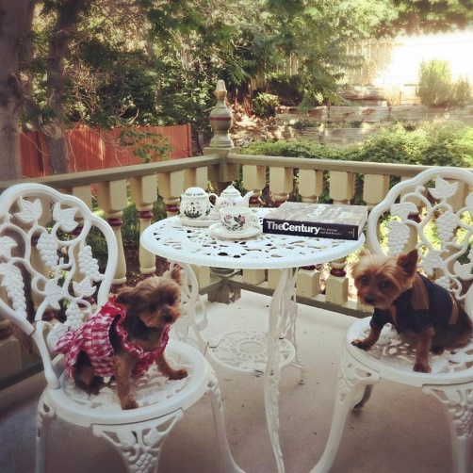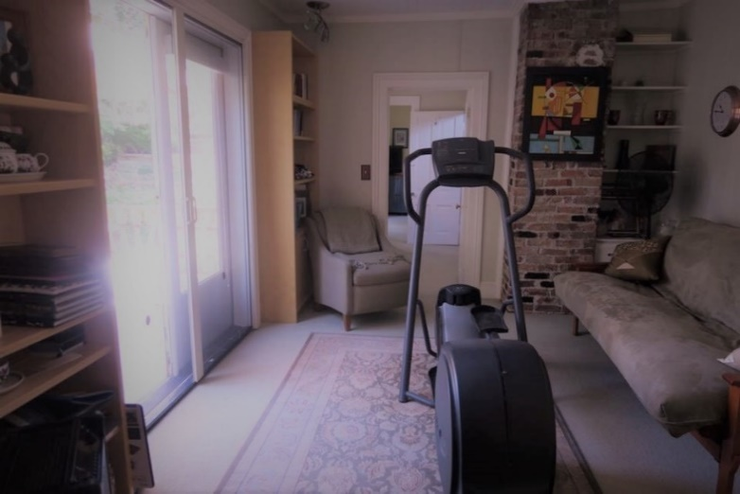

third floor
Local legend is that Mark Twain’s brass studded chamois money belt was found behind a post in the southwest corner wall of the third floor by Jack and Lorna Flannigan in the 1950s. Samuel Clemens lived in Virginia City from 1862 to 1863 and first used the pen name Mark Twain while reporting for The Territorial Enterprise. He was robbed during that time on the Gold Hill Divide. The problem with this legend is that if the house burned during the Great Fire of 1875 then it would be very difficult for Twain’s money belt to have survived from 1863 time period
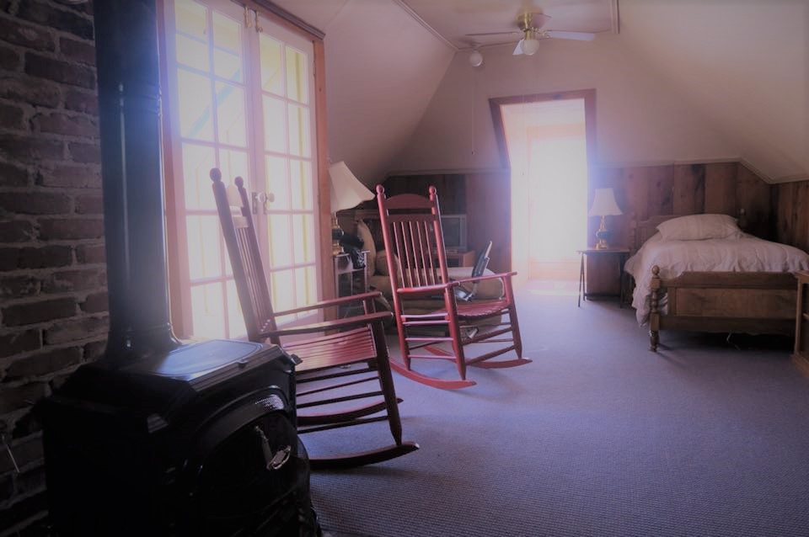

gardens
In 1990 Yandre and Teague commissioned the construction of the rock walls and gardens around the house by Din Cosart and Karl Larson. Joan Brown, a resident of Virginia City and the great granddaughter of naturalist John Muir, planted many of the plants that live on today.
Some of the oldest plantings are bright red oriental poppies brought to Virginia City during the mining days. The “Aunt Millie Irises” in the garden are a rare breed of Iris. The bulbs for these flowers were first brought to Virginia City in covered wagons by settlers on their way to California, they were given to the Jordt’s by friends and returned to Virginia City in the 1970s. Since then tea rose plants have been nurtured and have returned to bloom every year. A current project is the repair of the back fenced and upper terraces that were damaged by heavy winter snow.
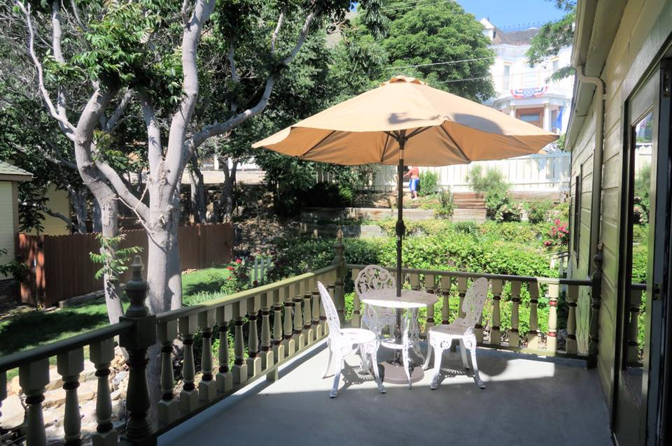
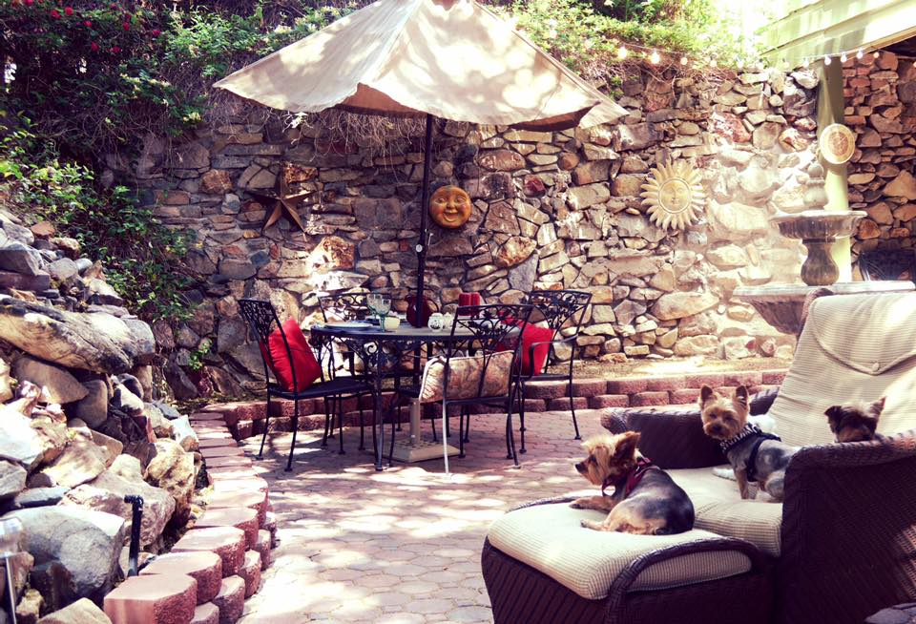
The garden photographs are from the present collection which include the 2nd floor deck view of the gardens, the brick patio and stone wall off the first floor French doors and views of the back, side and front gardens. The final photograph depicts the house at Halloween when the spirits of Virginia City-Past return on the Virginia and Truckee Railroad each year.

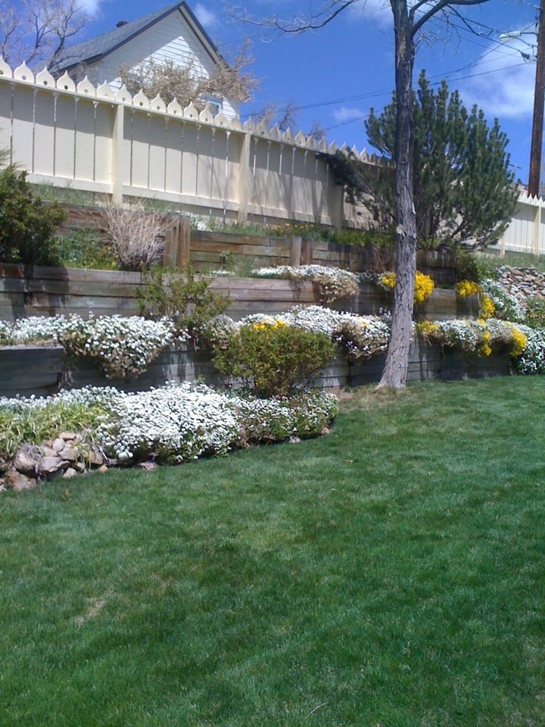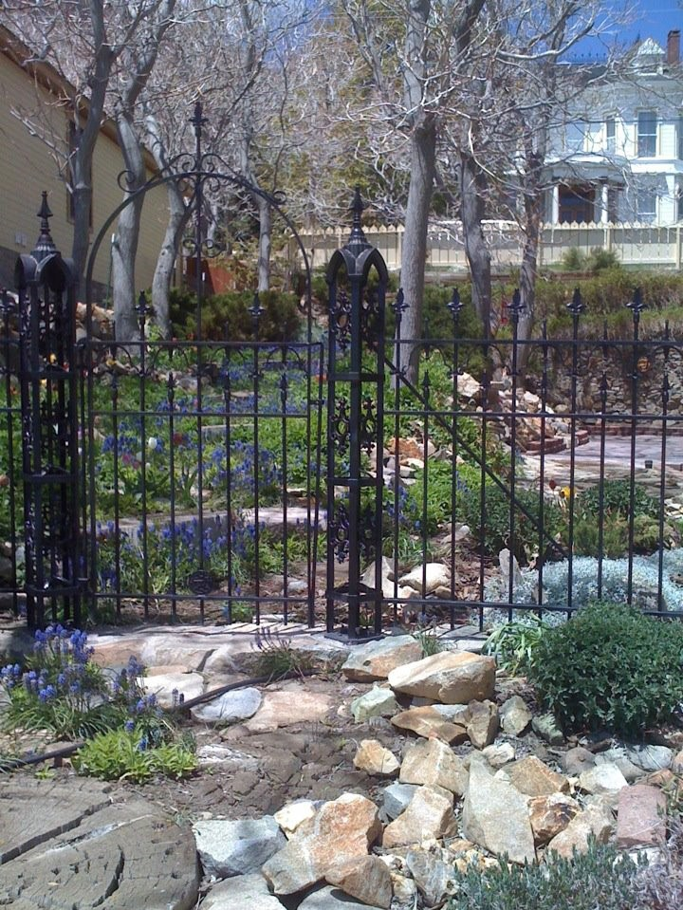
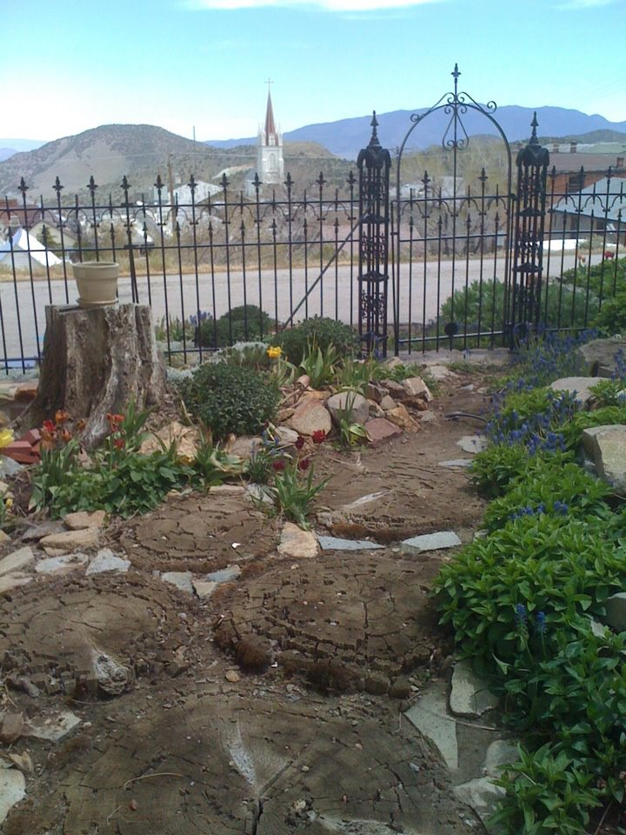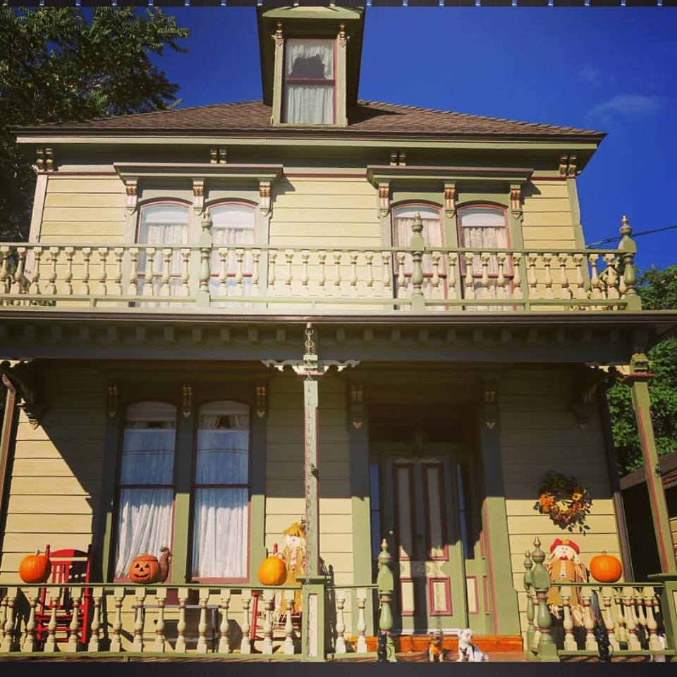

Trail of Ownership for Lot 13 Block 102 Range Howard Virginia City
- Hardy, R C to Virginia, Spencer
February 12, 1862 - $75
Book A Page 259
Spencer Virginia listed in 1862 NV Territory Directory as a miner residing on west side of A Street near Taylor. Stephen Virginia also resided there (brother?)
- Virginia, Spencer to Jacobs, Michael
June 7, 1862 - $200
Book B Page 601
A M Jacobs listed in 1862 NV Territory Directory as a shoemaker residing on west side of A Street near Union.(Same? Just prior residence?)
- Jacobs, Mich to Jacobs, Morris
November 17, 1862 - $500
Book G Page 244
- Jacobs, Morris to Jacobs, Michaelus
May 19, 1863 - $1,200
Book U Page 86
A notation that this was a reconveyance back to original seller.
- Jacobs, M & Henryetta to Jacobs, Morris
December 8, 1863 - $700
Book V Page 126
- Jacobs, Morris to Haase, Samuel
January 11, 1865 - $1,475
Book Z Page 324
- Haase, Samuel to Cohn, Leyser
July 8, 1865 - $1,000
Book Z Page 601
- Cohn, L to Jacobs, Ephraim
January 6, 1868 - $240
Book 32 Page 336
- Jacobs, E to Jacobs, M
October 10, 1872 - $200
Book 33 Page 174
A Michael Jacobs listed in 1873-74 Directory as a shoemaker residing on east side of Howard between Union and Taylor
- Jacobs, M to Lonkey & Smith (Lonkey, Oliver & Smith, E R)
December 29, 1877 - $6,000
Book 41 Page 651
An Oliver Lonkey is listed in the 1878 Directory residing at 48 South A Street, Lonkey brothers (?) are listed as residing at 107 Carson.(Eli, Oliver, William, and Xavier) Leon Lonkey at 338 south C (Nevada Lodging House, proprietor)
Lonkey & Smith is listed as Nevada and California Lumber Co. and Verdi Planning Mill at 102 north C.
An E R Smith is listed as residing at 102 North C
- Smith, E R & F J to Lonkey, Oliver
February 19, 1885
Book 46 Page 575
- Lonkey, Camille (Executor) & Marie (Widow) to Meacham, R. S.
November 9, 1905
Book 55 Page 469
- Meacham, R. S. Deceased June 10, 1912
- Kenney, H Estate to Storey County Treasurer Agnes Hamilton
1931
Information obtained from Treasurer’s Delinquent Tax Records
- Storey County Treasurer Agnes Hamilton to Kenney, E. L.
July 21, 1932 - $12.37
Book 61 Page 40
- Kenney, E.L. to Spaulding, Frank W
November 28, 1936
Book 62 Page 331
- Spaulding, Frank W. to Kenney, E.L.
January 20, 1947
Book 62 Page 541
- Kenney, E.L. to Kenney, David C.
June 28, 1948
Book 63 Page 110
- Kenney, David C to Flanagan, John
March 31, 1956
Book 64 Page 41
- Flanagan, John to Flanagan, Jack
- Krieger, Poole S to Jordt, David K & Rita S
June 13, 1973
Book 68 Page 59

